



**SM6P07NI Digital Media Project**

**20% Report**

**2022-23 Autumn**

**Student Name: Samaya Shrestha**

**London Met ID: 20049329**

**College ID: NP01MM4S210034**

**External Supervisor: Rupesh Dangol**

**Internal Supervisor Dibesh Maskey**

**Assignment Due Date: April 26, 2023**

**Assignment Submission Date: April 26, 2023**

**Word Count:**

*I confirm that I understand my coursework needs to be submitted online via Google Classroom under the relevant module page before the deadline in order for my assignment to be accepted and marked. I am fully aware that late submissions will be treated as non-submission and a marks of zero will be awarded.*

# Abstract

This project is about making 3D game assets in the context of Nepal. This project will consist of various types of Newari houses and also similar structures of buildings like Basantapur Durbar Square. This documentation will include all the details of the project.

This documentation contains details about the aim of the project, target audience, products research, plans, resources, testing and findings.

# Table of Contents

1. Abstract 2

1 Introduction 1

1.1 Topic 1

1.2 Area of Research 1

2 Aims of Project 2

3 Target Audience 3

4 Product Research 4

5 Technologies Employed 5

Maya: 5

Substance Painter: 5

In this project, it was used for creating textures for the models. 5

Twin motion: 5

6 Project Plan 6

7 Production Phases 7

Pre-Production 7

Production 7

Post-Production 7

8 Resources 8

8.1 Hardware resources 8

8.2 Software resources 8

9 User Testing & Findings 9

10 Conclusion 10

11 References 11

12 Bibliography 12

13 Appendix 13

# Table of Figures

Figure 1: Basantapur Gaddi Durbar 5

Figure 2: Durbar Square, Kathmandu 6

Figure 3: Planned timeline 8

Figure 4: Initial Timeline 8

Figure 5: Research on assets 9

Figure 6: Modelling assets 10

Figure 7: Texturing assets 10

Figure 8: Creating Environment 11

Figure 9: Final Compilation 12

# Introduction

## Topic

The topic of this project is “Basantapur Durbar Square”. This project is named Basantapur Durbar Square as the architectures made in this project are similar to the infrastructure located in the Basantapur Durbar Square and are made using them as reference point of the project.

## Area of Research

The research was done during the whole production process. The research was mainly done during the pre-production process as everything needed to be planned before the production as creating intricate props are not an easy task. During this phase, research was done on creating models, giving textures to the model, lighting, and rendering. The research process was also carried out during the production process as obstacles were faced during the production.

# Aims of Project

The aim of this project is to create a collection of 3D assets that is based on the architecture of Nepal which can be used for various purposes like game environment, game assets, animation, etc.

If made with high detail and precision it can also be used as a digital replica of ten architecture and can be preserved in the digital world for the upcoming generations.

These assets can be useful for 3D animators, game developers, and also other people who work in the field of 3D. These can also be use full for the animators for the creation of scenes.

In conclusion this is a project which is valuable for large number of people including game developers, animator, historians, etc. it also helps to understand and appreciate the Nepal’s history and culture.

# Target Audience

The target audience for the project are the people who may and can use the assets that created in the project. They may belong to various backgrounds who may use these assets in their own project. The audience can use these assets in various fields of 3D such as game development, environment development, animation, etc. These assets can also be used in movie production, series, etc. The audience may belong to any age group and gender but as per the research mostly the people above the age of 18 are found to use these assets for this project.

# Product Research

## Basantapur Gaddi Durbar

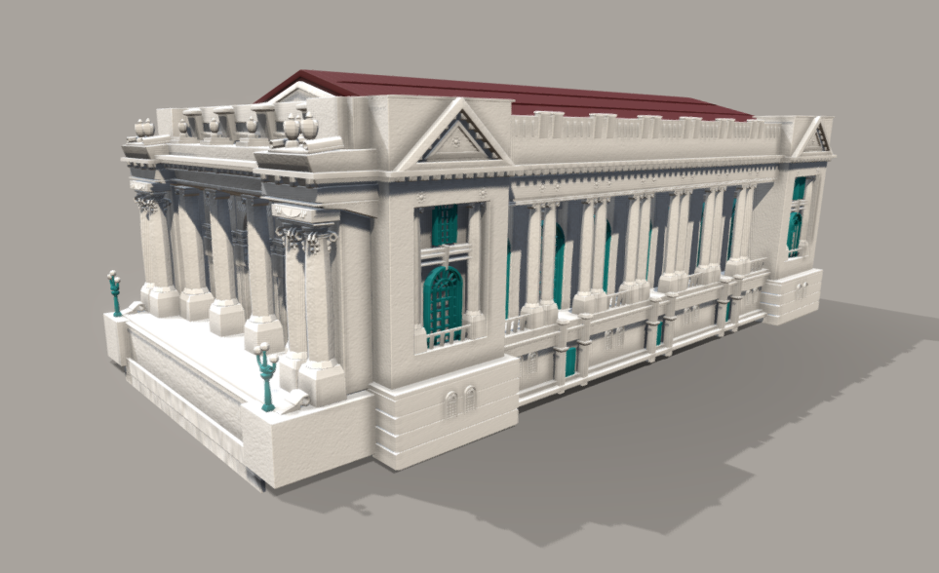

Figure 1: Basantapur Gaddi Durbar

The "Basantapur Gaddi Durbar'' by Ashim Shakya in SketchFab is an excellent and beautiful 3D low-poly model that showcases the use of old-school and new-school style of Nepali Architecture. It is based on the real-life structure that is located in Basantapur, Kathmandu, Nepal.

The attention to detail on each of the structure is done precisely with proper accuracy. The design primarily highlights the details of the pillars, doors, light poles at the opening of the building and windows.

The texturing and colour of the model are also done neatly which gives it a realistic look to the model. Most importantly, the colour of the marble, the tiles of the roof and the green highlights of the poles and windows are applied accurately with the real-life architecture.

Link to the 3D model: <https://sketchfab.com/3d-models/basantapur-gaddhi-durbar-gaddhi-palace-852bbf2c807b4c5bb6a37bef1e1fec24>

## Durbar Square, Kathmandu

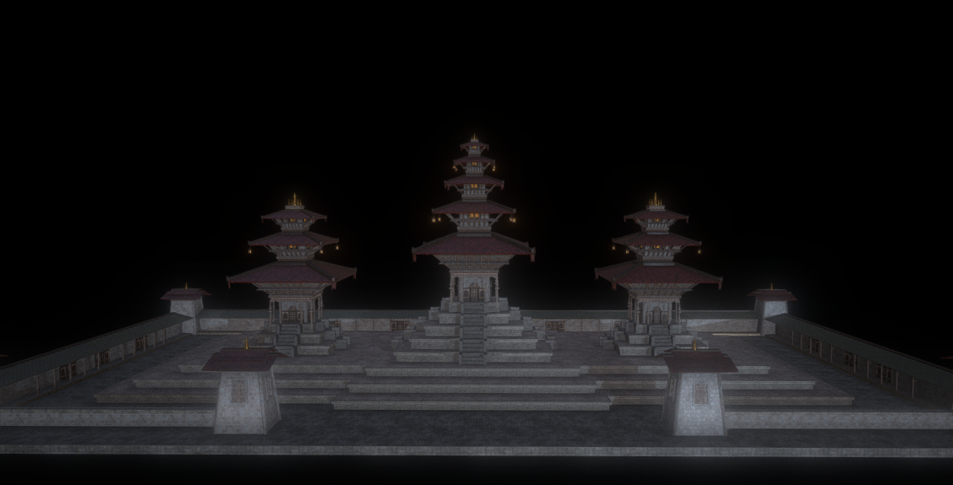

Figure 2: Durbar Square, Kathmandu

The "Durbar Square, Kathmandu" is a 3D model that has been created by Miguel Herrera in SketchFab is an outstanding model that represents the three-temple architecture of Durbar Square which is located in Patan, Lalitpur, Nepal.

The model is beautifully crafted and designed with proper attention to detail with its intricate designs on the wooden pillars, the roof tiles and the golden steeple on top which completes the overall look. Also, the platform-stairways, lamps at the edge of the roofs and the walls surrounding the temple have also been modelled properly.

The texturing has also been done well which highlights each of the models. The texture of the stone laid floors on the platform, the wooden texture on the pillars, the roof tiles and the golden steeple captures which attracts the attention and also portrays the scene accurately in comparison to the real-life scene.

Link to the 3D model: <https://sketchfab.com/3d-models/durbar-square-katmandu-5291d40e6efb4a35a33c3f81e0ad1f97>

# Technologies Employed

A variety of technologies were employed to create this project. For different steps of the creation process different software was used.

## Maya:

Maya is a 3D computer graphics software that is widely used in film, television, and game development industries. It is a comprehensive tool for creating 3D models, animations, and visual effects. Maya is known for its ability to handle complex 3D scenes, and its powerful animation and rendering capabilities.

In this project, it was used for the creation of props.

**Substance Painter:**

Substance Painter is a 3D painting software that is used for texturing and material authoring. It is designed to create high-quality textures for 3D models quickly and easily. Substance Painter uses a PBR (physically based rendering) workflow, which allows users to create realistic materials that respond to light in a physically accurate way.

In this project, it was used for creating textures for the models.

**Twin motion:**

Twin motion is a real-time 3D rendering and visualization software that is used for architectural visualization, urban planning, and interior design. It is designed to provide architects, designers, and engineers with a fast and easy way to create high-quality visualizations of their projects.

In this project, twin motion was used for creation of environment with models and rendering the scenes.

# Project Plan

The initial plan for the project was to create architectural structures of Nepal. The architectural structures, which was initially planned to be made are Basantapur Durbar Square, Gaddi Baithak, Kumari Ghar, Taleju temple along with some different style of houses in the area.

For the final plan some changes have been done to the initial plan. One architectural structure, which was planned to be made, has been reduced due to the lack of references. Except for that everything was done according to the initial plan of the project.

The only thing different apart from this is that the timeline, which was drawn before the project had to be changed, as per the requirement of the production process of the project.

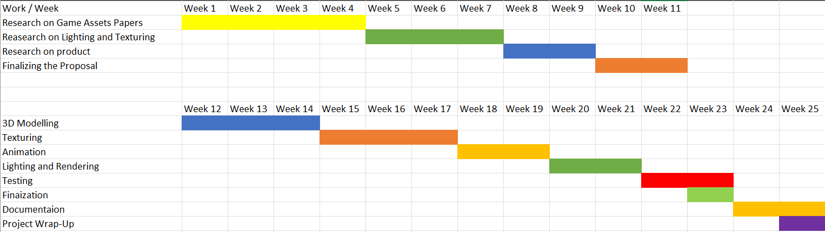

Figure 3: Planned timeline

Figure SEQ Figure \* ARABIC 1: Planned timeline

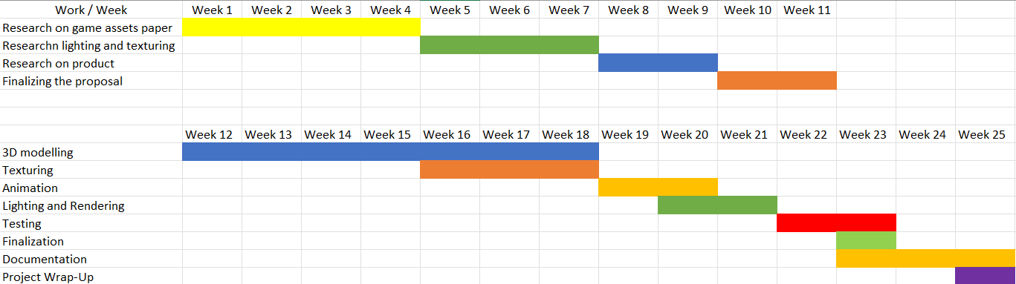

Figure 4: Initial Timeline

# Production Phases

The task of the project was divided into three types depending on the type of work to be done which are as follows:

## Pre-Production

This is the first phase of the production process. This is the phase where the tasks are done before the production process begins is completed. For this project, the tasks that were done during this phase includes research on the source and references, planning of the project, finalization of the assets, etc.

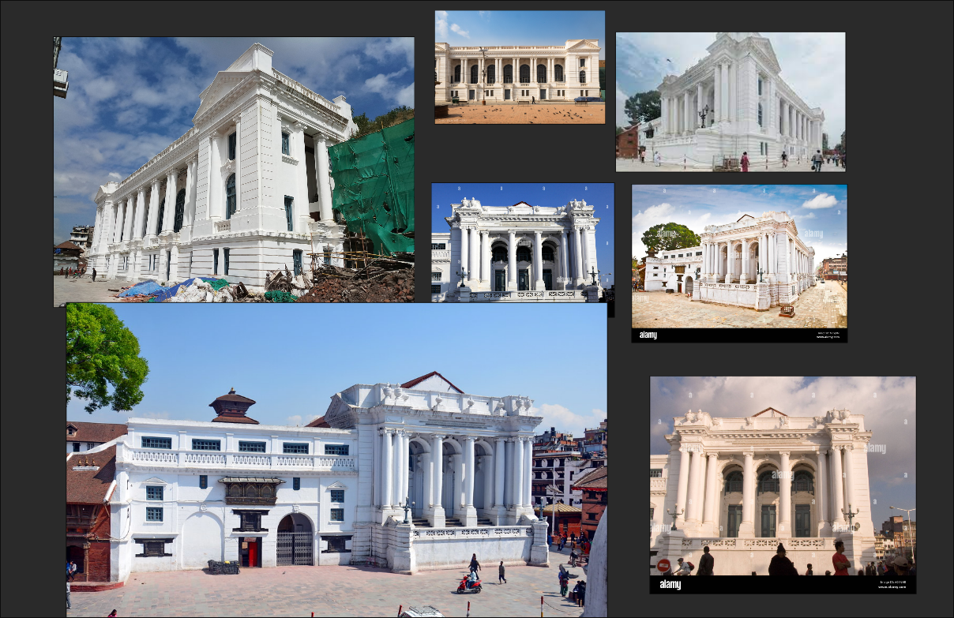

Figure 5: Research on assets

## Production

This is the second stage of the production process. This is the phase where all the work is done like creating assets and props, applying textures to the assets, and creating layout for render. For this project, the tasks that were done during this phase includes creating assets, texturing the assets, and arranging the layout in for the render.

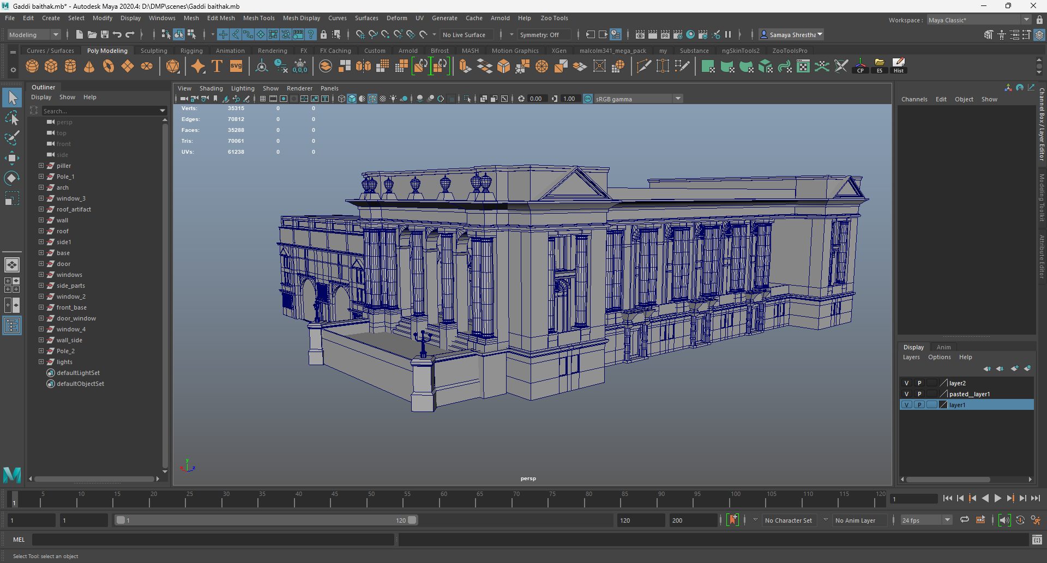

Figure 6: Modelling assets

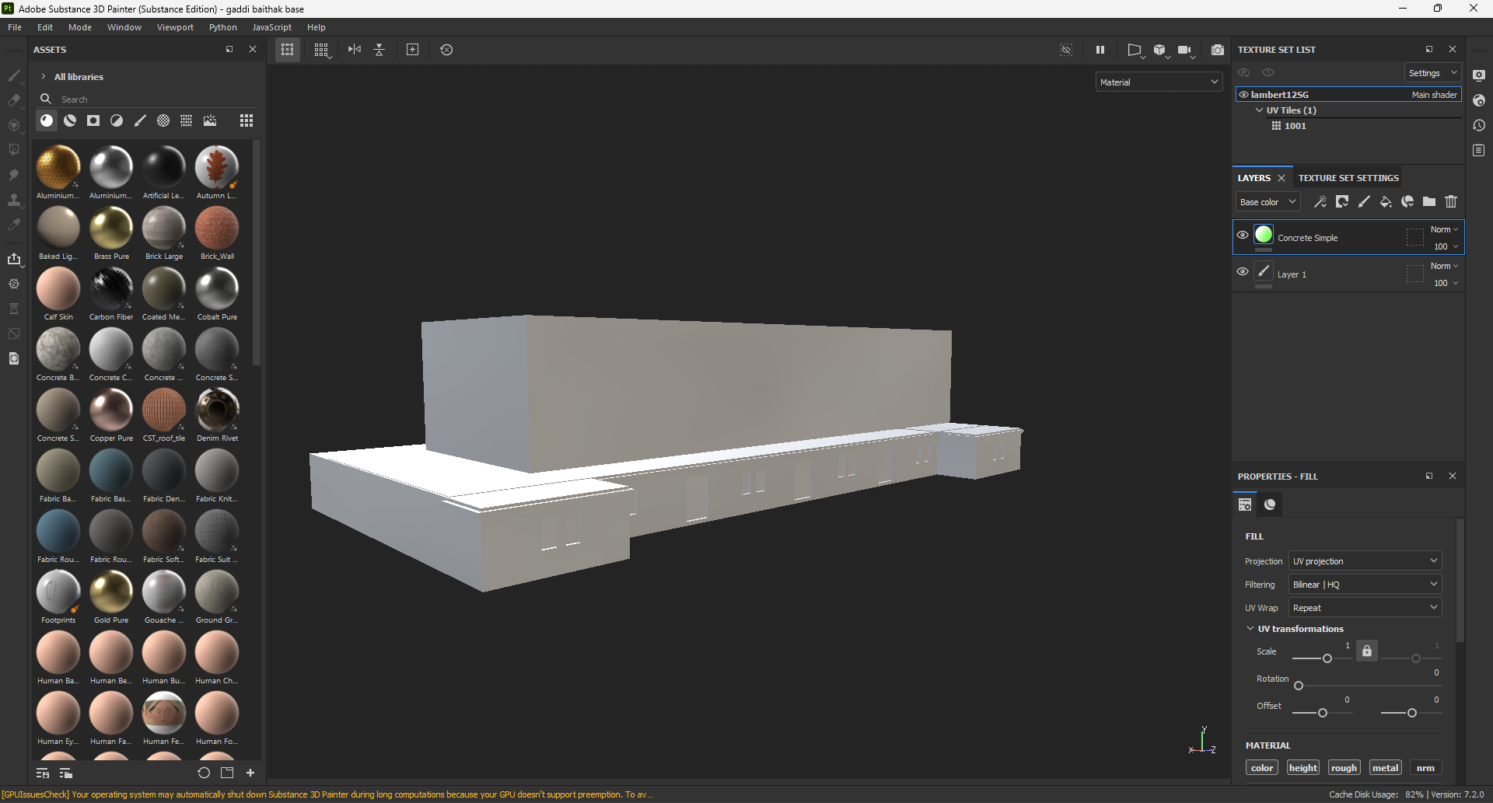

Figure 7: Texturing assets

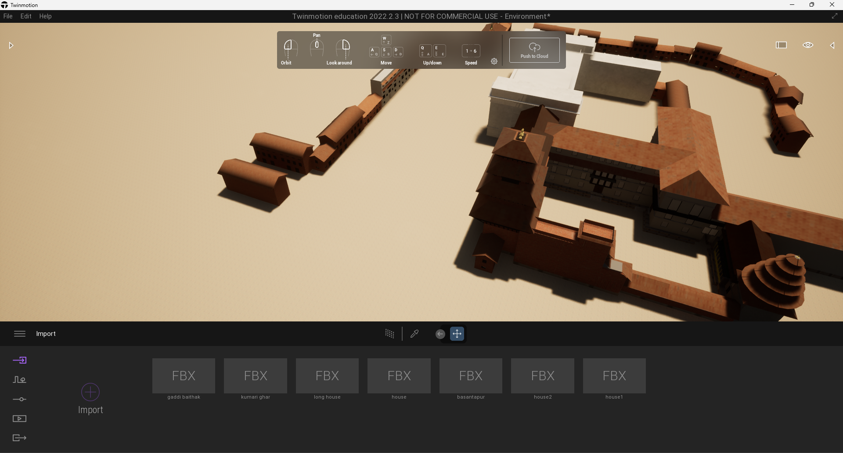

Figure 8: Creating Environment

## Post-Production

This is the third and the last phase of the production process. This is the phase where the compilation of the render is made, sounds are added and exported for the audience. For this project, the tasks that were done during this phase includes compiling the render files and adding sound in the video and exporting the final output of the render as video for the audience.

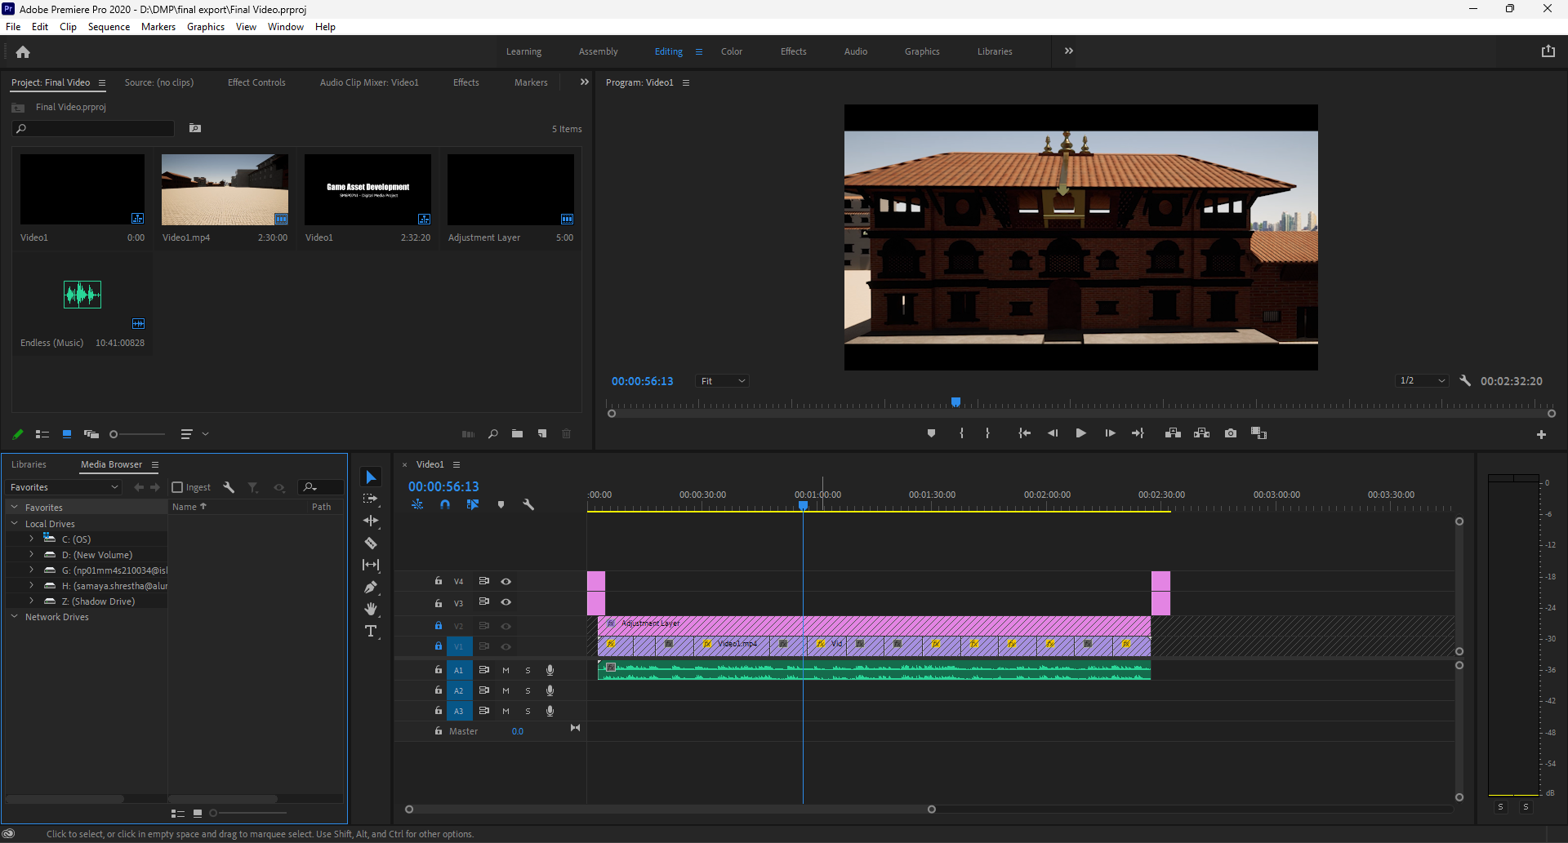

Figure 9: Final Compilation

# Resources

Resources that were used for this project are as follows:

## Hardware resources

Processor: Intel i5 9th Generation

GPU: Nvidia GeForce RTX 2060

RAM: 16 GB

Storage: 1.5 TB

Operating System: Windows 11

## Software resources

For modelling: Maya 2020

For Texturing: Substance Painter

For Rendering: Twin Motion

For Compilation: Adobe Premier Pro

# User Testing & Findings

A Google form was created for record the response of the audience about the project. It is understood that the audience was pleased with models that were created. They were also satisfied with the how the 3D models look. Here are the survey details and the questionnaires provided below:

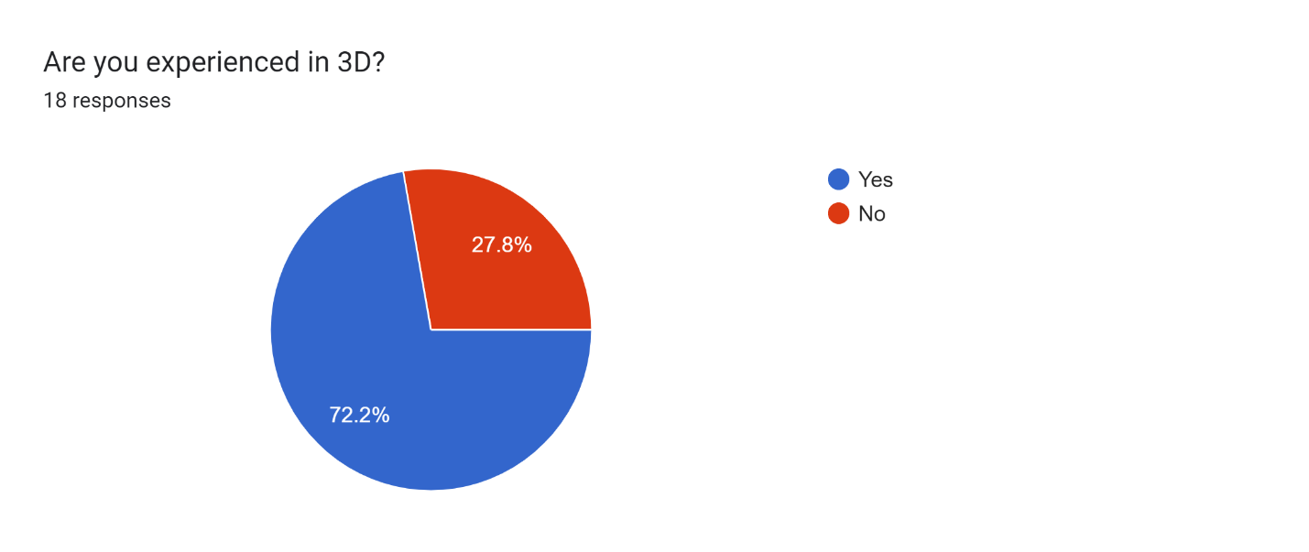

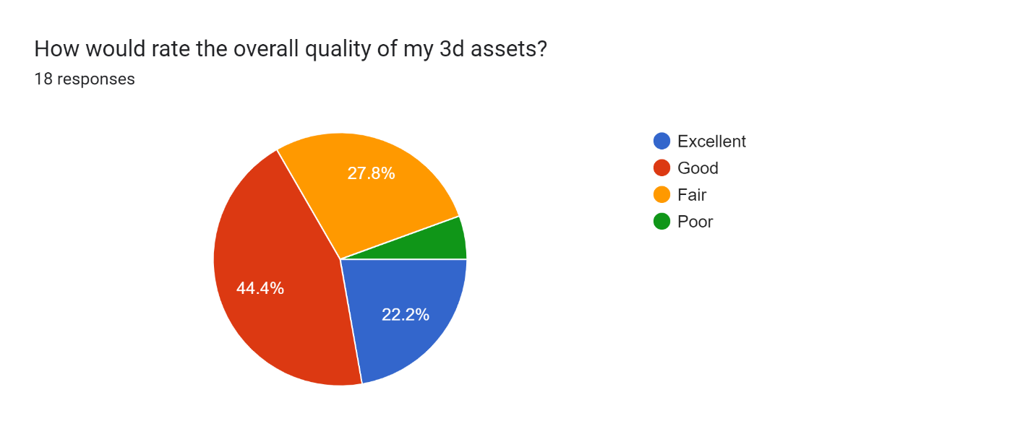

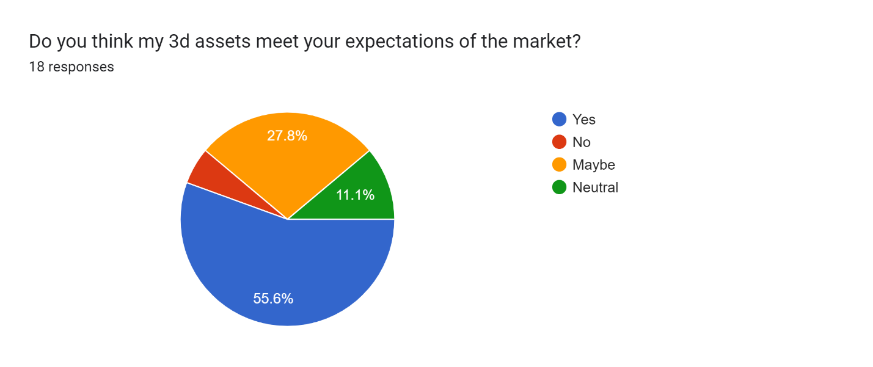

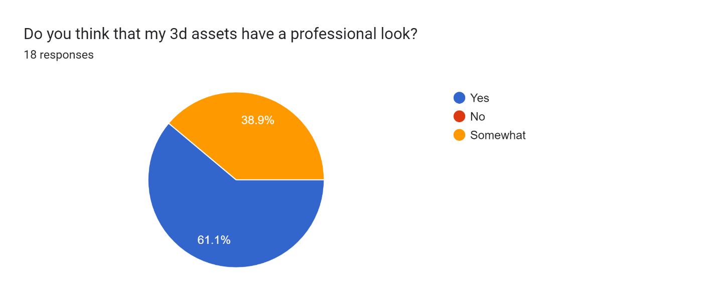

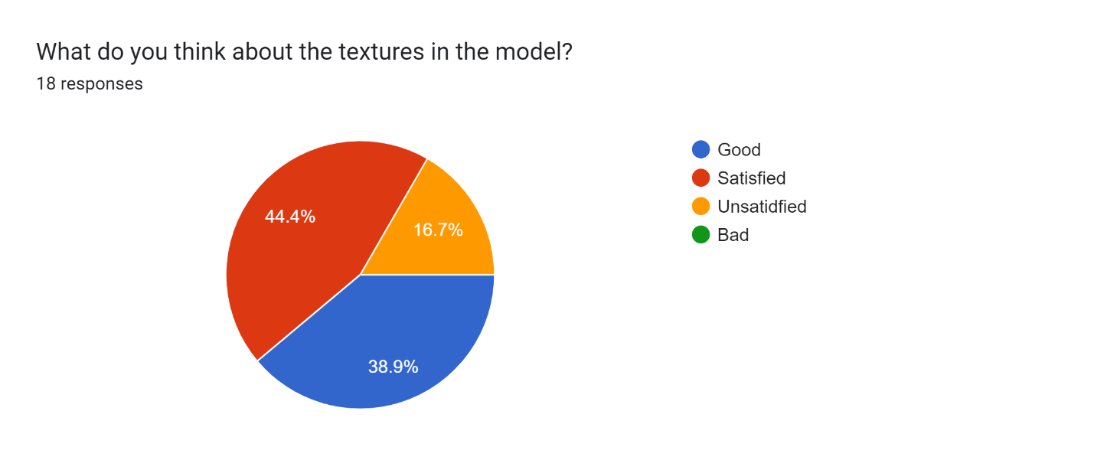

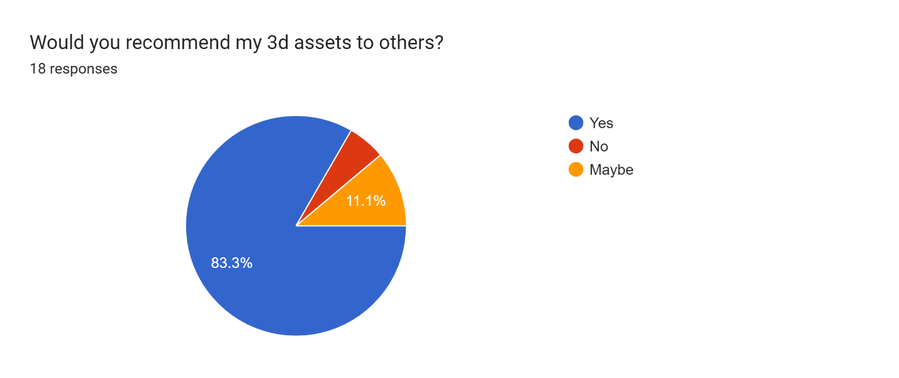

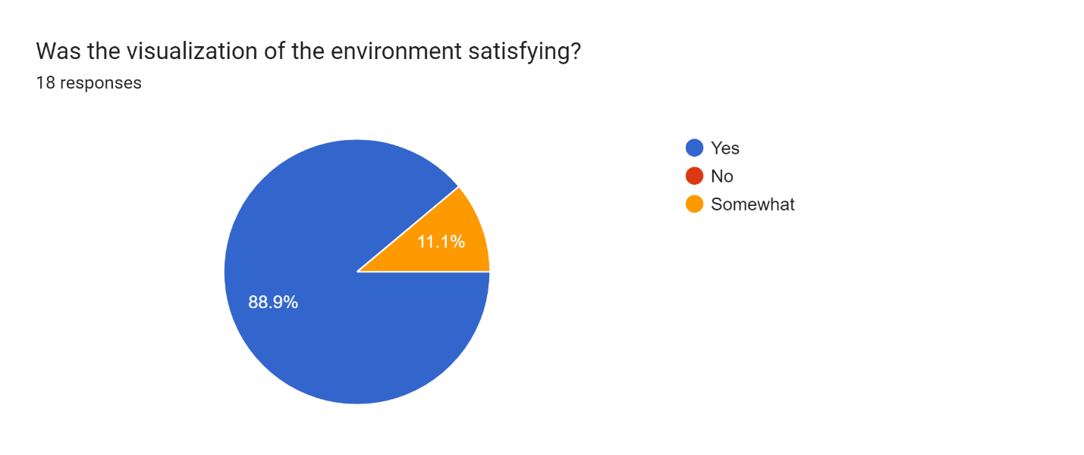

After the survey, the overall response of the audience is widely positive and have been in favour of the initial project. However, the audience have said that the texturing in the models could have been better than it currently is whereas some said that it is satisfying.

To conclude, this survey has provided an essence that clarifies the flaws of the product and has been refined and improved according to the feedback provided by the audience.

# Conclusion

The Digital Media Project has been very helpful as it allowed me to improve more on 3D which is my area of interest. It also helped me to increase my knowledge on 3d modelling, texturing, lighting, and rendering. 3D modelling was a tough process for the entire project as poly count of all the objects had to be kept as low as possible. UV unwrapping was simple as was texturing those UV maps.

However, exporting all the assets and textures into Twin motion and linking them was a hassle and took a lot of time. To understand this research was needed to understand how models and textures worked in Twin motion.

It was a challenging assignment which allows us to improve and gain extensive knowledge about our fields of interest.

# Links

The links of the final project video, the project files and the GitHub-backed files has been given below as follows:

## YouTube link:

<https://youtu.be/qGGVqN-sHmo>

## Drive

<https://drive.google.com/drive/folders/1-6sO6LNkKjL4Ovb0hZrnOGH9PZjf1gbT?usp=share_link>

## GitHub

<https://github.com/SamayaStha/DMP-Coursework>

# References

* All3DP, n.d. *What Is Substance Painter? – Simply Explained.* [Online]   
  Available at: https://all3dp.com/2/what-is-substance-painter-simply-explained/  
  [Accessed 2023].
* Wikipedia, n.d. *Adobe Premier Pro.* [Online]   
  Available at: https://en.wikipedia.org/wiki/Adobe_Premiere_Pro  
  [Accessed 2023].
* Wikipedia, n.d. *Autodesk Maya.* [Online]   
  Available at: https://en.wikipedia.org/wiki/Autodesk_Maya  
  [Accessed 2023].
* Wikipedia, n.d. *Twinmotion.* [Online]   
  Available at: https://fr-m-wikipedia-org.translate.goog/wiki/Twinmotion?_x_tr_sl=fr&_x_tr_tl=en&_x_tr_hl=en&_x_tr_pto=sc  
  [Accessed 2023].

# Bibliography

* All3DP, n.d. *What Is Substance Painter? – Simply Explained.* [Online]   
  Available at: https://all3dp.com/2/what-is-substance-painter-simply-explained/  
  [Accessed 2023].
* Wikipedia, n.d. *Adobe Premier Pro.* [Online]   
  Available at: https://en.wikipedia.org/wiki/Adobe_Premiere_Pro  
  [Accessed 2023].
* Wikipedia, n.d. *Autodesk Maya.* [Online]   
  Available at: https://en.wikipedia.org/wiki/Autodesk_Maya  
  [Accessed 2023].
* Wikipedia, n.d. *Twinmotion.* [Online]   
  Available at: https://fr-m-wikipedia-org.translate.goog/wiki/Twinmotion?_x_tr_sl=fr&_x_tr_tl=en&_x_tr_hl=en&_x_tr_pto=sc  
  [Accessed 2023].

# Appendix

## Survey Reports















## Logbook

